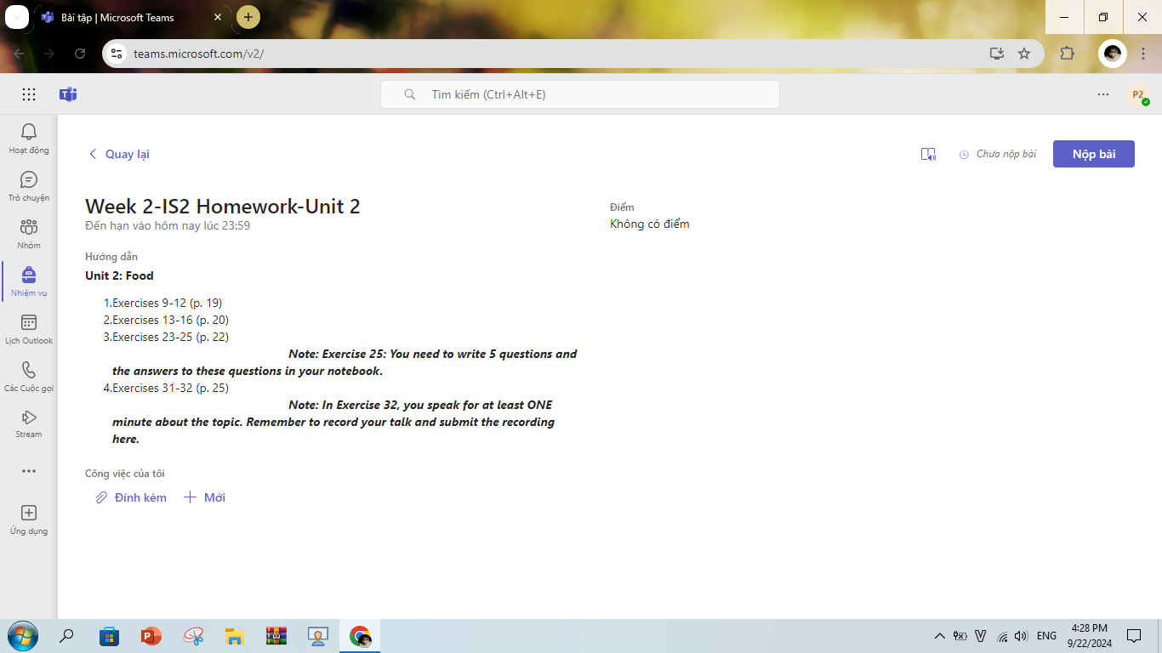
Today I will tell you about a small party meal that I enjoyed.
That was on the 3rd day of Tet 2023.My classmates and I invited each other to my teacher's house to celebrate the New Year.We started on the road at 8:00 and arrived at the teacher's house at about 8:45.When we arrived, we were treated to soft drinks and candy by the teacher.We sat around for a while and my teacher very enthusiastically invited us to stay for lunch. My teacher treated us to a chicken hot pot meal with lots of vegetables.
Besides, there are also pork, pork sausage, pickled onion and banh chung. We have soft drinks and beer to drink.it was a very delicious meal.During the meal we happily told stories to each other.We also told each other what we were planning to do in the future.After the meal we stayed to sing karaoke and at 2pm we started to return home.That day was very great because we could play together and return home safely.I will never forget those happy moments

